Brigitte Bardot, Famous People Stamp S/Sheet MNH  0 Bids: $6.50  Time left:2d 21h 6m | Brigitte Bardot, Famous People Stamp S/Sheet MNH  0 Bids: $6.50  Time left:2d 21h 6m | Sheryl Crow, Famous People Stamp S/Sheet MNH  0 Bids: $6.50  Time left:2d 21h 6m

Sheryl Crow, Famous People Stamp S/Sheet MNH  0 Bids: $7.50  Time left:2d 21h 6m | Sheryl Crow, Famous People Stamp S/Sheet MNH  0 Bids: $7.50  Time left:2d 21h 6m | Michael Jackson, Famous People Postage Stamp MNH  0 Bids: $3.00  Time left:2d 21h 7m

Metallica, Rock Band Postage Stamp MNH  0 Bids: $3.00  Time left:2d 21h 8m | Bono from U2 Rock Band Postage Stamp MNH  0 Bids: $3.00  Time left:2d 21h 8m | Michael Jackson Set of 3 Postage Stamps MNH 2009  0 Bids: $9.00  Time left:2d 21h 8m

Bono from U2 Rock Band Postage Stamp MNH  0 Bids: $3.00  Time left:2d 21h 8m | Nicolas Cage, Famous People Postage Stamp MNH  1 Bid: $3.00  Time left:2d 21h 9m | Depeche Mode, Famous People Postage Stamp MNH  0 Bids: $3.00  Time left:2d 21h 9m

Jennifer Aniston, Famous People Postage Stamp MNH  0 Bids: $3.00  Time left:2d 21h 10m | Eva Longoria, Famous People Postage Stamp MNH  0 Bids: $3.00  Time left:2d 21h 10m | Ann Sheridan, Famous People Postage Stamp MNH  0 Bids: $3.00  Time left:2d 21h 10m

Lucy Liu, Famous People Postage Stamp MNH  0 Bids: $3.00  Time left:2d 21h 10m | Pamela Anderson, Famous People Postage Stamp MNH  0 Bids: $3.00  Time left:2d 21h 10m | Jennifer Aniston, Famous People Postage Stamp MNH  0 Bids: $3.00  Time left:2d 21h 11m

Ritchie Blackmore, Deep Purple Postage Stamp MNH  1 Bid: $3.00  Time left:2d 21h 12m | Sharon Stone, Famous People Postage Stamp MNH  0 Bids: $3.00  Time left:2d 21h 12m | Ritchie Blackmore, Candice Night Postage Stamp MNH  0 Bids: $3.00  Time left:2d 21h 12m

David Caruso 2 Different Postage Stamps MNH  0 Bids: $6.00  Time left:2d 21h 12m | Beyonce 2 Different Postage Stamps MNH  0 Bids: $6.00  Time left:2d 21h 13m | Sheryl Crow 2 Different Postage Stamps MNH  0 Bids: $6.00  Time left:2d 21h 13m

Paulette Goddard 2 Different Postage Stamps MNH  0 Bids: $6.00  Time left:2d 21h 13m | Pamela Anderson, Famous People Postage Stamp MNH  0 Bids: $3.00  Time left:2d 21h 14m | John Wayne, Famous People Postage Stamp MNH  0 Bids: $3.00  Time left:2d 21h 14m

James Dean, Famous People Postage Stamp MNH  0 Bids: $3.00  Time left:2d 21h 14m | Kim Delaney, Famous People Postage Stamp MNH  0 Bids: $3.00  Time left:2d 21h 15m | Grace Kelly, Famous People Postage Stamp MNH  0 Bids: $3.00  Time left:2d 21h 15m

1,443 results found in all categories
View as:Gallery
Sort by:Time: ending soonest
Shipping to USA
Afghan Hound Dog Postage Stamp MNH  0 Bids: $3.50  Time left:2d 8h 20m | Airedale Terrier Dog New Postage Stamp MNH  0 Bids: $3.50  Time left:2d 8h 21m | Bedlington Terrier Dog New Postage Stamp MNH  0 Bids: $3.50  Time left:2d 8h 21m

Bloodhound Dog New Postage Stamp MNH  0 Bids: $3.50  Time left:2d 8h 27m | Border Collie Dog New Postage Stamp MNH  0 Bids: $3.50  Time left:2d 8h 30m | Borzoi Dog New Postage Stamp MNH  0 Bids: $3.50  Time left:2d 8h 30m

Boxer Dog New Postage Stamp MNH  0 Bids: $3.50  Time left:2d 8h 30m | Briard Dog New Postage Stamp MNH  0 Bids: $3.50  Time left:2d 8h 32m | Brittany Spaniel Dog New Postage Stamp MNH  0 Bids: $3.50  Time left:2d 8h 32m

Bull Terrier Dog New Postage Stamp MNH  1 Bid: $3.50  Time left:2d 8h 32m | Chinese Crested Dog New Postage Stamp MNH  0 Bids: $3.50  Time left:2d 8h 34m | English Cocker Spaniel Dog New Postage Stamp MNH  0 Bids: $3.50  Time left:2d 8h 34m

Dachshund Dogs New Postage Stamp MNH  0 Bids: $3.50  Time left:2d 8h 35m | Dalmatian Dog New Postage Stamp MNH  0 Bids: $3.50  Time left:2d 8h 35m | Doberman Dog New Postage Stamp MNH  0 Bids: $3.50  Time left:2d 8h 36m

English Pointer Dog New Postage Stamp MNH  0 Bids: $3.50  Time left:2d 8h 36m | Wire Fox Terrier Dog New Postage Stamp MNH  0 Bids: $3.50  Time left:2d 8h 37m | Gordon Setter Dog New Postage Stamp MNH  0 Bids: $3.50  Time left:2d 8h 37m

Great Dane Dog New Postage Stamp MNH  0 Bids: $3.50  Time left:2d 8h 38m | Great Pyrenees Dog New Postage Stamp MNH  0 Bids: $3.50  Time left:2d 8h 39m | Irish Red Setter Dog New Postage Stamp MNH  0 Bids: $3.50  Time left:2d 8h 39m

Labrador Retriever Dog New Postage Stamp MNH  0 Bids: $3.50  Time left:2d 8h 39m | Alaskan Malamute Dog New Postage Stamp MNH  0 Bids: $3.50  Time left:2d 8h 40m | Mastiff Dog New Postage Stamp MNH  0 Bids: $3.50  Time left:2d 8h 40m

Pug Dog New Postage Stamp MNH  0 Bids: $3.50  Time left:2d 8h 41m | Rough Collie Dog New Postage Stamp MNH  0 Bids: $3.50  Time left:2d 8h 46m | Samoyed Dog New Postage Stamp MNH  0 Bids: $3.50  Time left:2d 8h 46m

Shar Pei Dog New Postage Stamp MNH  0 Bids: $3.50  Time left:2d 8h 47m | Weimaraner Dog New Postage Stamp MNH  0 Bids: $3.50  Time left:2d 8h 47m

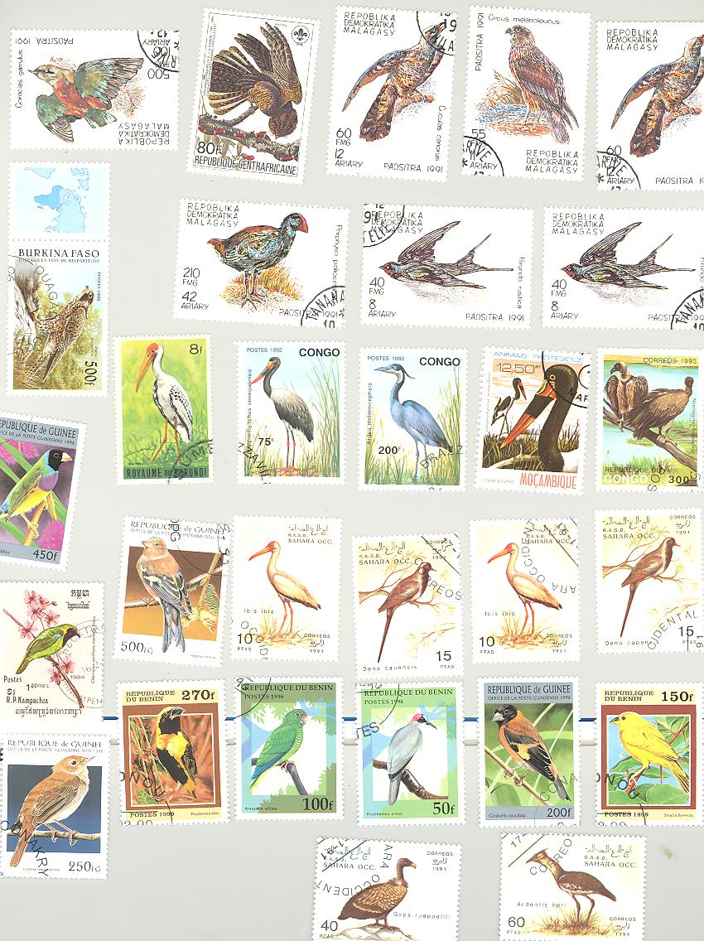

DJIBOUTI - Djibouti 2007 "Marilyn Monroe" sheetlet of six stamps (700CF) (NOTE: THESE STAMP-LIKE LABELS WILL BE LISTED BY THE UPU AS ILLEGAL AND UNAUTHORIZED ISSUES. WE OFFER THEM BECAUSE THEY ARE ON THE MARKET, AND WE RECOMMEND THAT YOU BUY THEM ONLY IF YOU LIKE THEM. - From: Marlen Stamp & Coins Ltd. - Sheet of 6: US$ 13.95 / Sheet Imperf: US$ 39.95 –

BENIN - Benin "Marilyn Monroe" set of three sheets (each containing six stamps) (NOTE: THE ORIGIN OF THESE STAMPS MAY BE QUESTIONABLE AND MAY BE LISTED AS ILLEGALS. WE THEREFORE SUGGEST THAT YOU BUY THEM ONLY BECAUSE YOU LIKE THEM. WE OFFER THEM BECAUSE THEY ARE ON THE MARKET.) - From: Marlen Stamp and Coins Ltd., USA – Sheet of 6: US$29.85

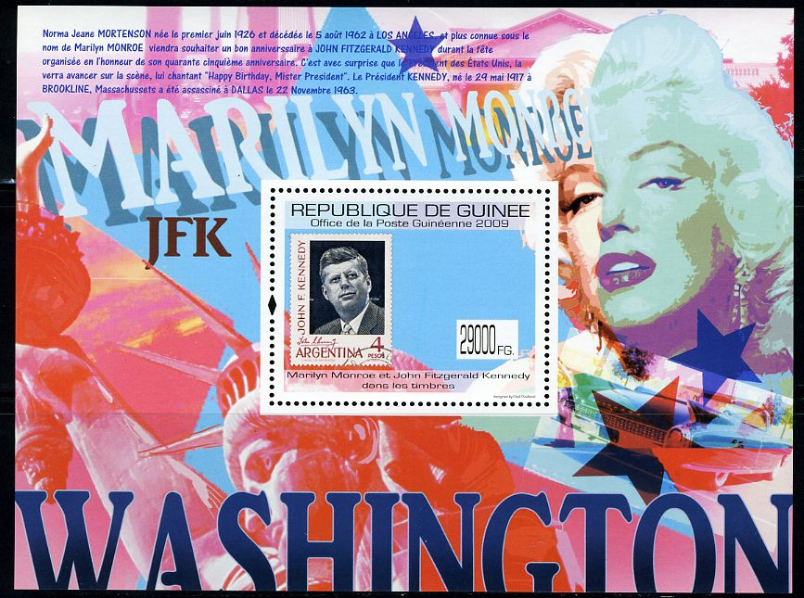

GUINEA - Guinea 2010: "John F. Kennedy and Marilyn Monroe of Postage Stamps" Souvenir sheet showing a stamp from Argentina that depicts resident John F. Kennedy, images of Marilyn Monroe and the Statue of Liberty are also seen
From: Marlen Stamp & Coins Ltd. - Souvenir Sheet: US$ 14.95 / Souvenir Sheet FDC: US$ 20.95 / Souvenir Sheet Imperf: US$ 49.95 / Souvenir Sheet FDC Imperf: US$ 55.95

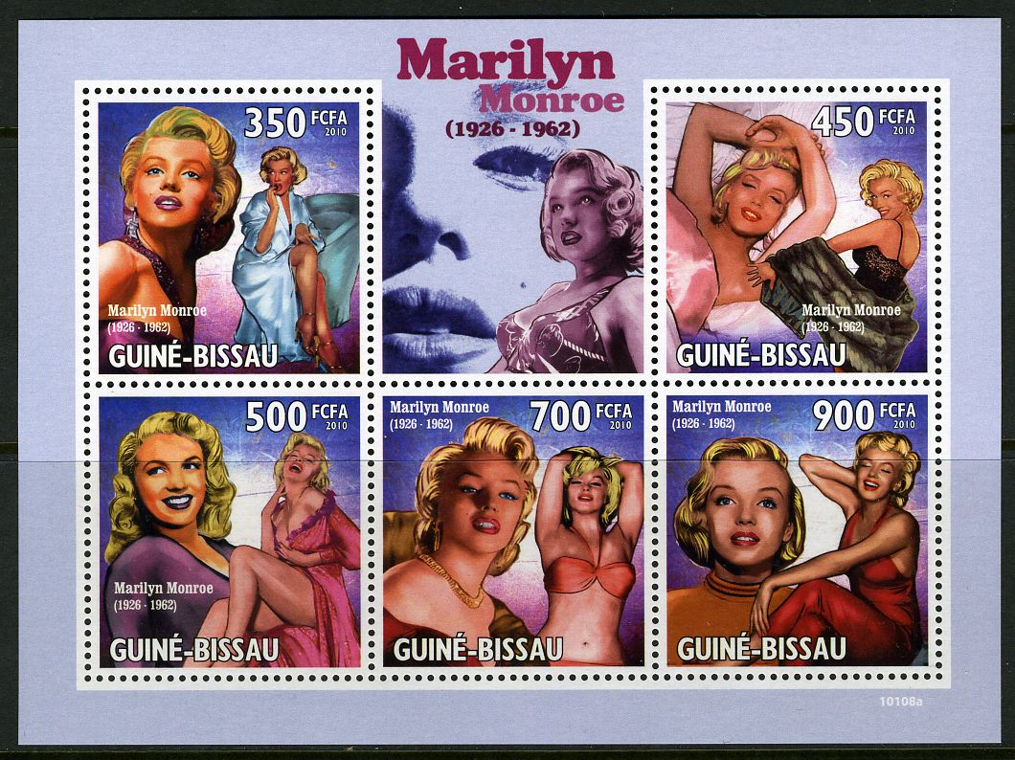

GUINEA-BISSUA - Guinea Bissau 2010: "Marilyn Monroe" Sheetlet of five stamps honoring Marilyn Monroe
From: Marlen Stamp & Coins Ltd. - Sheet of 5: US$ 14.95 / Sheet FDC: US$ 20.95 / Sheet Imperf: US$ 49.95 / Sheet FDC Imperf: US$ 55.95

What we believe to be two illegal stamps in name of Uganda sold from two East Europe based Internet sites

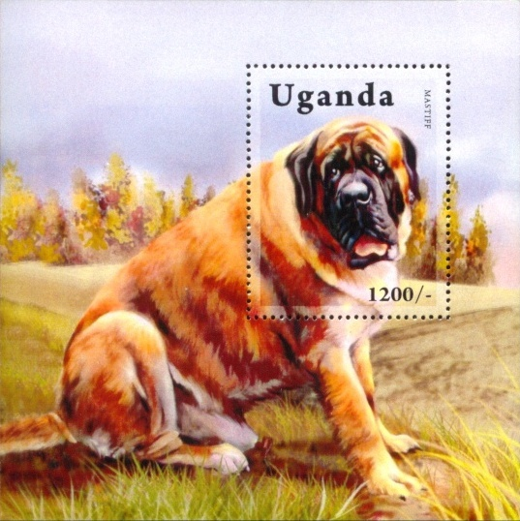

Mastiff Dog New Stamp Souv. Sheet MNH - Price: US$ 6.95- 3 available

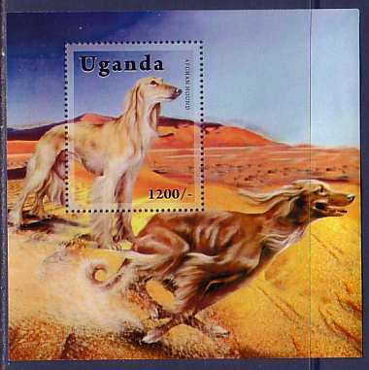

Afghan Hound Dogs MNH S/S stamp - Price: US$ 7.00

We are not certain of following one:

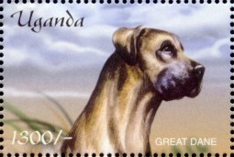

Great Dane Dog Art Postage Stamp Uganda MNH - Price: US$ 3.50 - 2 available
